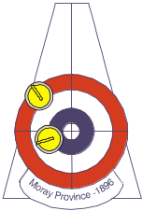

ROYAL CALEDONIAN CURLING CLUB

MORAY PROVINCE

MINUTES OF THE COMMITTEE MEETING

Held at the Laichmoray Hotel
On Sunday 16th of November 2014

PRESENT
C Macgregor (President), N Durno, M Pickthall, G Scott, A Cameron, M Clark, W Nicol, H Clark, S MacIver, M McInnes, J Farquhar, C MacIver, D Patterson, C Ross.

- APOLOGIES
Apologies were received from A Maltman, A Campbell, M Pottie and M McKenzie.

- CORRESPONDENCE
The Secretary had received a report from the Convener of the Moray Province Curling Development Group (Appendix 1) which was read to the meeting.
A letter of thanks had been received from Alan Stanfield thanking the Committee for the presentation made to him at the AGM on behalf of the Province.

- MINUTES OF COMMITTEE MEETING HELD ON 23rd FEBRUARY 2014
The Minutes were approved; proposed by Hamish Clark and seconded by Mike McInnes.

- MATTERS ARISING
Bill Nicol asked for clarification regarding his status on the Committee as Webmaster. It was agreed that the Webmaster had no voting rights and that the Executive would discuss, at their next meeting, whether or not the Webmaster should attend Committee meetings.

- FINANCIAL UPDATE
The Treasurer updated the Committee on the Province’s finances which he stated were reasonably healthy. (Statement of Account; Appendix 2). One club had still not paid their entry fees or subs; the Secretary undertook to speak to the club concerned.
Nairn Curling Club arranged group insurance for the Province trophies and would bill the Treasurer for the annual premium.

- MATCH SECRETARIES’ COMPETITION REPORTS
The Match Secretaries delivered their respective competition reports (Appendices 3 & 4)

- WEBSITE UPDATE
Bill Nicol informed the Committee that he was pleased with the new website which was an improvement on the previous RCCC website; he still had some material to transfer from the previous site but was making progress. He appealed for more submissions of news and items of interest from the clubs.

- ELECTION OF CLUB REPS
The Constitution presently requires that clubs submit the names of their Province reps so that they can be voted onto the Province Committee at the AGM. Invariably this has proved to be difficult because a complete list of Province reps has not always been available on the night. The Executive wish to amend the Constitution to allow a nominated voting club member to attend committee meetings at the AGM to vote on behalf of their club; the attendance sheet would include a column to indicate whether that member was the club’s nominated voting member. The Committee agreed that the wording of the Constitution should be amended for adoption at the next AGM.

- DISTRIBUTION OF AGM MINUTES
Following a query regarding the distribution of the un-adopted AGM minutes, the Committee agreed that they should be posted on the website in draft form as soon as practical after the meeting.

- HONORAY MEMBERSHIP
The Committee unanimously agreed to propose two Province members for honorary membership at the AGM.

- PLANT REPLACEMENT AT MLC AND INVERNESS ICE CENTRE UPDATE
It was reported that there was no further update on the proposed plant replacement and ice rink upgrades at the Inverness Ice Centre although action was taking place behind the scenes.
Campbell Ross, Moray Province’s representative on the ICE4ALL group, was invited to address the Committee on the latest situation regarding the plant replacement at MLC. He presented a report on the current situation (Appendix 5) and answered questions from the floor. He concluded that it was now time to re-convene the Moray Province MLC Sub-Committee Review Group to discuss the way forward with ICE4ALL. The President thanked him for taking the time to attend.

- MLC COMPETITION WINNERS’ BOARDS UPDATE
Andy Cameron reported that he was still waiting for a price to update the competition winners’ boards and was reluctant to go ahead with the work at this stage while there was still some uncertainty over the future of the ice rink. He stated that there did not appear to be any deterioration in the condition of the boards as a result of their location and confirmed that they had all been photographed for the records. It was pointed, however, out that one of the boards did appear to be showing some signs of deterioration; Andy undertook to investigate.

- AOCB
- It was pointed out from the floor that the MPCDG was a Province sub-committee and therefore their report should appear as an agenda item. The Secretary agreed to ensure that this would be done in future.
- An update on the arrangements for the forthcoming Swiss Tour was requested. The President stated that a rink would represent the Province to play against the Swiss followed by dinner in the evening.
- The Secretary was requested and agreed to write a letter to the MLC board of management thanking them for the consistently good ice which Mathew Lackie and his team of technicians were providing.
- Bill Nicol asked the Executive to consider venues in Forres for future meetings, being more or less equidistant between Nairn and Buckie. The Executive agreed to consider suitable venues.
- It was pointed out that Moray Province had not made any monetary contributions to any of the Area 10 competitions last year as had been requested. It was explained that a letter had been sent to Johnston and Carmichael requesting sponsorship for the J & C Bonspiel to be held in Inverness without success. In the event, the Bonspiel was not played because of insufficient entries. It was suggested that because the quality of the ice at MLC is consistently good, consideration should be given by Area 10 to holding the J & C in Elgin as it was in the past.
- Bill Nicol suggested that the Moray Province standing orders and procedures should be followed or where necessary changed or updated. The Secretary agreed to liaise with Bill to discuss what might be required.

- DATE OF NEXT MEETING
The next Committee meeting will be held on Sunday the 1st of February.

There being no further business the President thanked everyone for attending and the meeting closed at 9.00pm.

M A Pickthall
Province Secretary

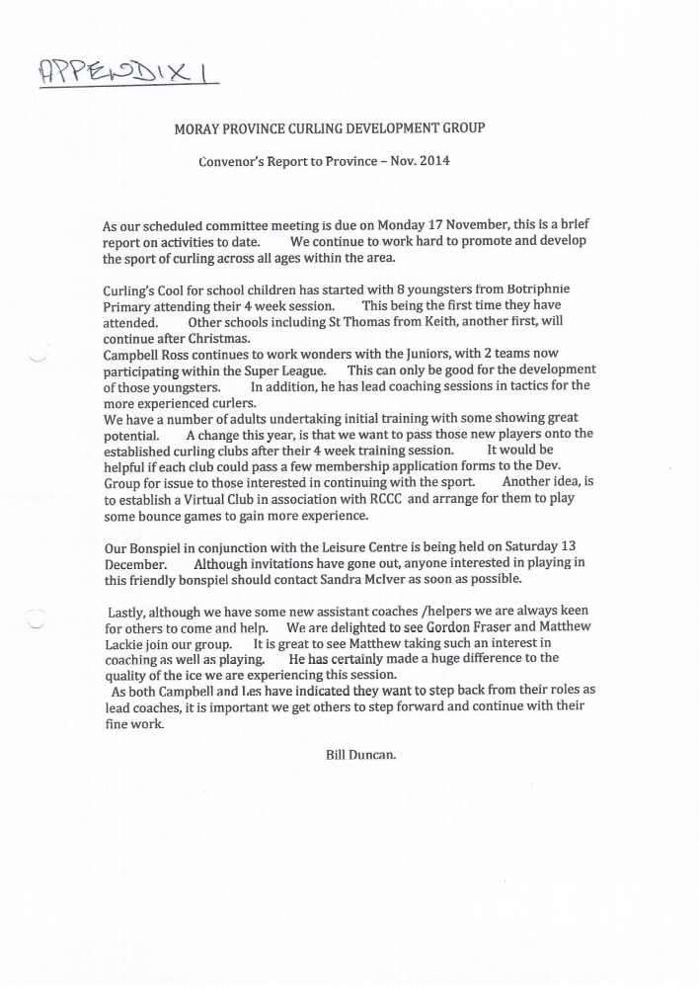

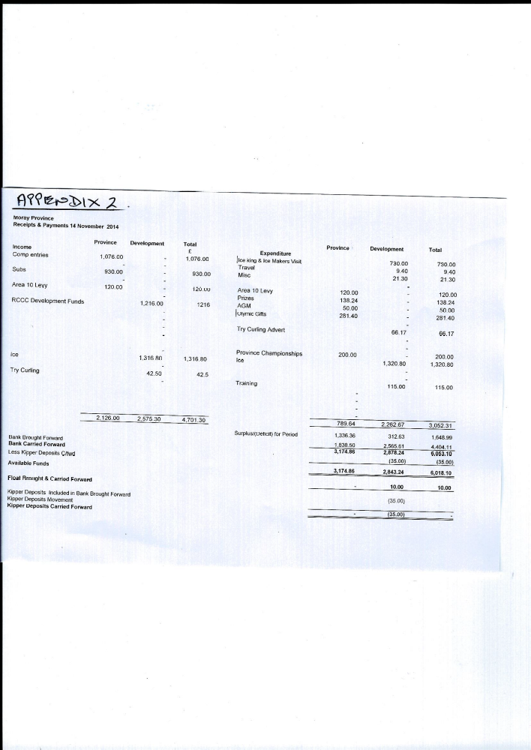
APPENDIX 3
Moray Province East report

Moray Province East's season is well under way with excellent ice both before and after the holiday period. The work that Matthew and the other ice techs have put in for this season is very impressive. Division One have only played one game so far with A Duncan, G Nicol and A Campbell all with one win.
Division Two have played 2 games with K Oswald and M MacDonald leading the way with 2 wins each.
Division Three have played 2 games with E Milne, L Scott and A Cameron having won both their games.
Division Four have played 3 games with A MacDonald leading the way with 3 from 3.
Division Five this season has only 5 teams with 3 of the teams being junior teams which is great. This shows the great coaching and progress that the Moray Junior Curling Club and Development group are making to the young curling at Elgin. Two games have been played with C Jacklin leading the way with 2 wins from 2.

The Moray Province Open mixed KO was split into East and West for the first couple of rounds to try and get more club/teams to enter. In the East there was one extra team which on the night never turned up for their game. Two rounds have been played at Elgin with the four teams that’s left going into the hat with the four teams from the West to make up the quarter-finals which are to be played at Elgin on Wednesday 26th November at 1900. Semi-finals are due to be played at Inverness on Monday 15th of December at 2135. After checking the teams that are through to the semi-finals it has come to my attention that there will be a clash with the Moray Super-league in Elgin. I have another date for the semi-finals to be played on Thursday 15th January to solve this problem.

There is still 6 spaces available to fill the Moray Province Mixed pairs on Tuesday 11th March starting at 1800 at Elgin.
Draw is the same as sent out bar one team. Please make sure all club members know of this.

I hope everything is in order and if you have anything you want to know please ask.

Thank you and good curling for the rest of the season.

APPENDIX 4
Moray Province West Report

In Inverness the season got under way with the League Winners competition in September and this saw the second division trophy return to Moray, or Nairn to be precise, courtesy of Mike McInnes whose rink won this section. It is now planned for the League winners and the Knockout competitions to be played on the same day and next year this will be on Saturday 28th March. It will mean that the League Winners Competition will be played twice this season but it is hoped that this will help to ensure better support for this fixture in the future.

Our leagues games are now well under way. In Division 1 Neil MacArthur’s Ardclach rink continue to dominate, whilst in Division 2 the Nairn teams of Ali Asher and Larry Kerr have made a strong start in their quest to return to the top division. We now only have 5 teams in Division 3 which is a shame, after our Highland Junior team withdrew from Moray Province at the end of last season.

Our opening/only round in the Open Knockout has taken place and I would like to thank Nairn Ladies for entering at the last minute to replace a team which had withdrawn. Their rink skipped by Margaret Pottie has progressed to the quarter final stages along with Ali Asher, Dean Clark and Mike McInnes from Nairn. We are now looking forward to meeting up with the teams from the East in Elgin on the 26th of this month.

Our juniors continue to do well in various competitions. Ellie Fraser from Dalcross and Callum Greenwood, Ardclach have been in the winning rinks in the Greenacres and Kinross under 21 events respectively, as well as competing abroad in the European Junior circuit.

Neil MacArthur’s Ardclach rink of Ally Fraser, Rhuaridh Greenwood and Neil Campbell represented Moray in the Province Championships at Greenacres this weekend. They won three out of four games and were second in their group, but unfortunately this wasn’t quite enough to qualify for the final stages.

APPENDIX 5
Subject: Report

On behalf of the Moray Leisure Centre Review Group appointed by Moray Province I will give a short report on the replacement plant in the MLC and to highlight some important other items that may have significant implications to these works.
To remind you Ice4All we joined ICE4ALL in 2010 due to the concerns that curlers and other ice users had on the way that MLC were operating and to the poor response and forward preventative maintenance being applied to the plant.
The Moray Province Moray Leisure Centre Review Group invited curlers last season to attend a meeting in the Forres Tollbooth to discuss what could be done to put pressure on the MC and MLC to ensure that a replacement plant would be installed rather than a drop in system. At this meeting, it was agreed that two representatives would be requested to join Ice4All to replace Mike Pickthall and Mike Watt to ensure that the curling fraternity's voice was being heard. Myself and N.Durno were nominated. W.Nicol was already part of the group as Vice President and Grigor Ewen Moray Wheel Chair CC was requested by ICE4ALL to join the group as the representative for disabled ice users.
The group was formalised with the other ice users a Constitution created and adopted with all meetings recorded and minutes issued and displayed in the ice rink
So far, this group has had much success and been in consultation with both MLC and MC with respect to the replacement plant. It is due to the pressure applied by Ice4All that MC at a special meeting on the 2nd July 2014 agreed to a complete replacement plant rather than a drop in system and that officers could appoint an external consultant to assist them with this project
It was not till 23rd September that a consultant was appointed to give a report on the existing plant, and options to replace. This also included upgrades to the building fabric.
It was not until 10th October that the consultant had a site meeting on the Thursday with TMC & MLC and on the Friday he met with two representatives from ice for all myself Campbell Ross and from skating Jon Behari along with a representative from TMC to discuss with our concerns and aspirations.
The report was due last week i.e. W/C 3rd November but it was delayed by a week and to my knowledge is now with the MC. It may take up to four months to evaluate and issue to competitive tendering and this may result in any works being delayed to outwith the curling season 2014 - 2015
Sports Scotland have confirmed their willingness to extend the 50% grant should the work commence after the 31st December 2014 date.
The current problems are that the consultant has identified that by 2020, only two refrigerants will be available by law to use and any new plant may have to be altered to suit. This could have a bearing on the option that MC accepts. I Campbell Ross have researched this statement but cannot find any documentation to back this up.
On a separate but important note, two individuals who are currently members of Ice4All have decided that they are not prepared to wait until the plant fails or MC decline to upgrade the plant and have sought an alternative location and sponsor to build a new ice rink. This is a private initiative by individuals who have a business plan and has no involvement with curling. However, by the very fact that they have announced this plan, it does put severe pressure on any potential replacement plant and both MC and MLC are aware of this plan and negative comments have been given by MLC. I can confirm that the curling delegation within Ice4All have also made their feeling known and that as a group, we must still proceed with haste to replace the existing plant.
As such, I inform the Moray Province to ensure that all members are informed that any discussions regarding a new ice rink is nothing to do with curlers or Ice4All.
It is hoped that the MC will release their options and decisions at the earliest to alleviate fears of any retraction from a replacement plant at MLC
Campbell
Late note
Graeme Summers said I am not personally involved in any direct discussions regarding the project at Milltown Airfield that is in the hands of Jon Behari and Rick Simmers, the interest started when looking for a place we could use as a backup if the plans at the MLC ended up with an extended closure due to plant breakdown even before the council had given the go ahead to the consultant to put in place an alternative to what we have at present in the MLC.
Costing and sourcing is the highest priority right now for a temporary pad however the land lords were very interested in how a new venture could be taken forward and that has stirred up their thought process in case the worst comes to the worst and the MLC does not come up with their project. They are doing this as individuals not representing ICE4ALL

