Queen's Birthday Honours List. 2017
Dr Alan Campbell Stanfield (Nairn C.C.)
Awarded M.B.E. for services to Curling.

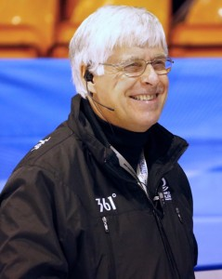
17th Of June 2017 we wake up to GOOD news following weeks of horrendous news of acts of terrorism in the UK and an unprecedented fire of unbelievable proportions in a tower block in London.
The good news came from H.M. the Queen in her Birthday Honours List, The Queen’s Birthday Honours lists 2017 recognise the achievements of a wide range of extraordinary people from across the UK. In total 1,109 people have received an award and off that only 5% were awarded for services to sport and in Alans case services to Curling. (Shown in working gear.)
Thank you to those who nominated Alan for this award it is so well deserved and I am sure will be humbly accepted by a truly well-deserved recipient.
Alan deserved this accolade for his efforts on and off the ice, his enthusiasm blossomed from the early eighties when he came to Nairn and took up curling for the first time, from that day on he has treated curling as a sport he loves to play and a sport he is willing to put back all he gets out of it.
On the ice he played club curling, local, national competitions and bonspiels in ice rinks all over Scotland, Alan was well known in curling circles wherever he went to play as a very competitive curler but also participated in the social side after the game, mind you in saying that one had to put up with playing every end again in detail whether he won or lost a game, you put up with it as he was a gentleman who had no bias, who gave his opinions as he saw it whether to his own team or the opposition.
Stepping away from Alan’s achievements at Club and Province level I think I would be right in saying his greatest curling memory has to be as a member of The Centenary Tour of Canada 2003 playing for and winning the Strathcona Cup. (Alan was Vice Captain touring the West) this plus winning The Scottish SENIORS Mixed Championship with Lindsay Scotland’s Murrayfield Rink.
Around 1999 to 2003 he became the curling guru in Moray Province in fact further afield in Area 13 (which was Area 10).
Moray Province 1999 to 2003
Alan was elected Vice President to Alan Durno in 1999 and served 4 years on the Executive (Alan’s new title for the High Heed Yins in the Province) the last two of four as our President.
He streamlined the rules of the Province competitions checking the wording dotting the I’s and crossing the T’s he ran every scenario through his head and as we all know he is the master of the rules to this day. The Province constitution got the same Stanfield treatment with every sentence scrutinised and corrected where required. The Province has now a set of rules and a constitution that even neighbouring Provinces and the Area crib from.
Now the most prestigious part, Umpiring and Time Keeping: - Alan started in 1997 and has since built up an unrivalled CV of major events he has officiated at here in Scotland and round the World for the Royal Club and the W.C.F.
Alan’s theory the Role of Umpire is you should not be seen and not be heard (Not easy in itself for Alan) but obviously he was seen by the RCCC and the WCF who recognised his abilities for detail and decorum and so through the years he progressed to various prestigious events, The Perth Master’s European events, World Junior Championships at home and abroad, Wheelchair World Championships, Men’s World Championships, The last two Olympics, European Championships and as I am going to miss something I will give up now.
As well as continuing to curl, umpiring and time clocks, Alan still finds time for running courses for aspiring umpires both here in the UK and in Europe it’s his way of giving something back to the sport of curling in which he has such a passion.
For the last couple of years Alan has played with an under 21 team in the Elgin Super League skipped by Molly Keen who coincidentally has been awarded a place in the Royal Club Academy. The Academy is a Scottish Development Programme supported by The Royal Caledonian Curling Club. The RCCC intends to build a strong pathway which delivers and aligns with the World Class Programme and which identifies and develops athletes.
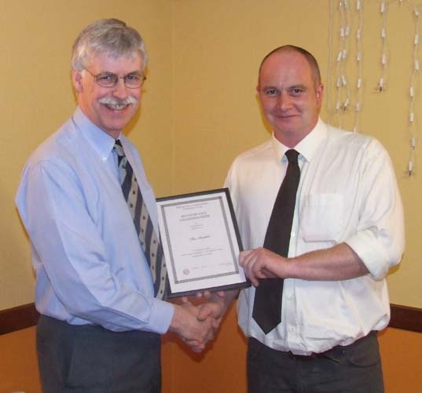
When Alan resigned from the Province he was made an Honorary Member of Moray Province and there was some speculation as to what he was going to do now and the way it was left was: - Alan is going to continue to curl as often as other onerous curling duties permit.
Gavin Nicol Province President Awards Alan his Honorary Membership

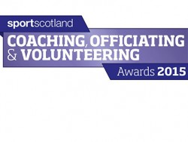

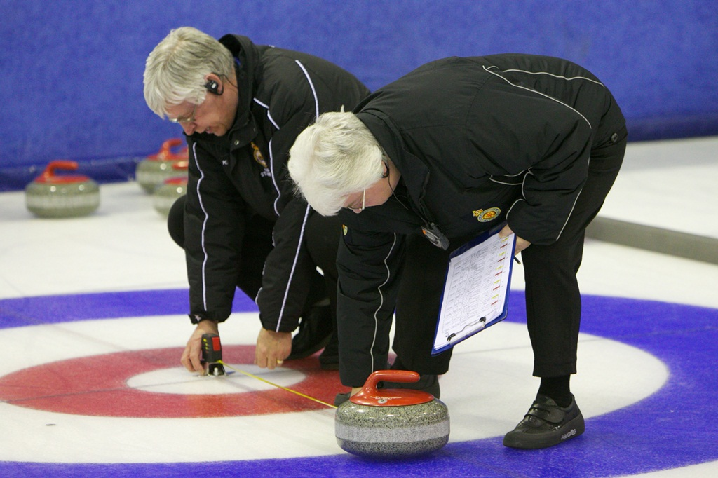
Who forgot to drill the hole?
In Summary
I have tried to give you an insight to Alan Stanfield’s (Nairn C.C) and Moray Province’s Curling Ambassador, as he deserves all the accolades associated with him with the M.B.E. being a most fitting recognition.
Good luck to you Alan in your future voluntary work and thank you I am sure from all curlers worldwide, the Royal Club and W.C.F for your dedication and enthusiasm to our SPORT OF CURLING.

